1
- Because the positive charge is going to propel the negative charge making it to go into the goal post.
- When one uses the positive to the positive charge they will repel each other propelling the positive charge to the goal post
When positive charge combines with positive charge they will attract two charges that will be directly opposite to each other.
- They are going to produce a neutral force that is going to counsel out each other.
- Placed two charged positive charges in between the pluck at a distance of about 6cm and they were not equidistant to each other.
This created a neutral point through which the pluck passed in. the obstacle were two negative charges slightly parallel to each other which would create a neutral path through which would repel the pluck to the goal where we had placed a negative charge.

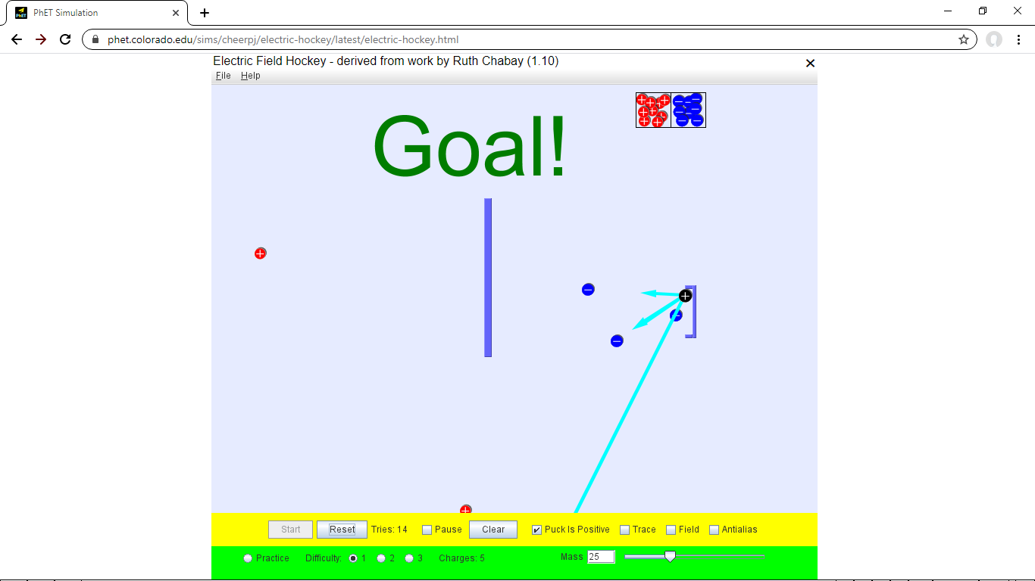
2.
a. electric field lines and show there interactions.
b. that is the positive force away(upward) while that of negative comes into the negative charge slightly shorter.
c. it will move towards the negative charge
d. the red line would look towards the positive charge while the negative would move away.
e.
f. in the negative charge the arrow is pointing to the charge. Meaning the fields will be moving toward each other.
While that of positive charge the charges will be moving away so is the line.
The field line will always pointing the direction in into which the pluck will be moving.
G. here we will be using a positive pluck which is going to be attracted by the negative charge at the bottom part.
While at the top there is positive charge at the bottom while at the goal post there is a negative charge which will attract the positive charge.
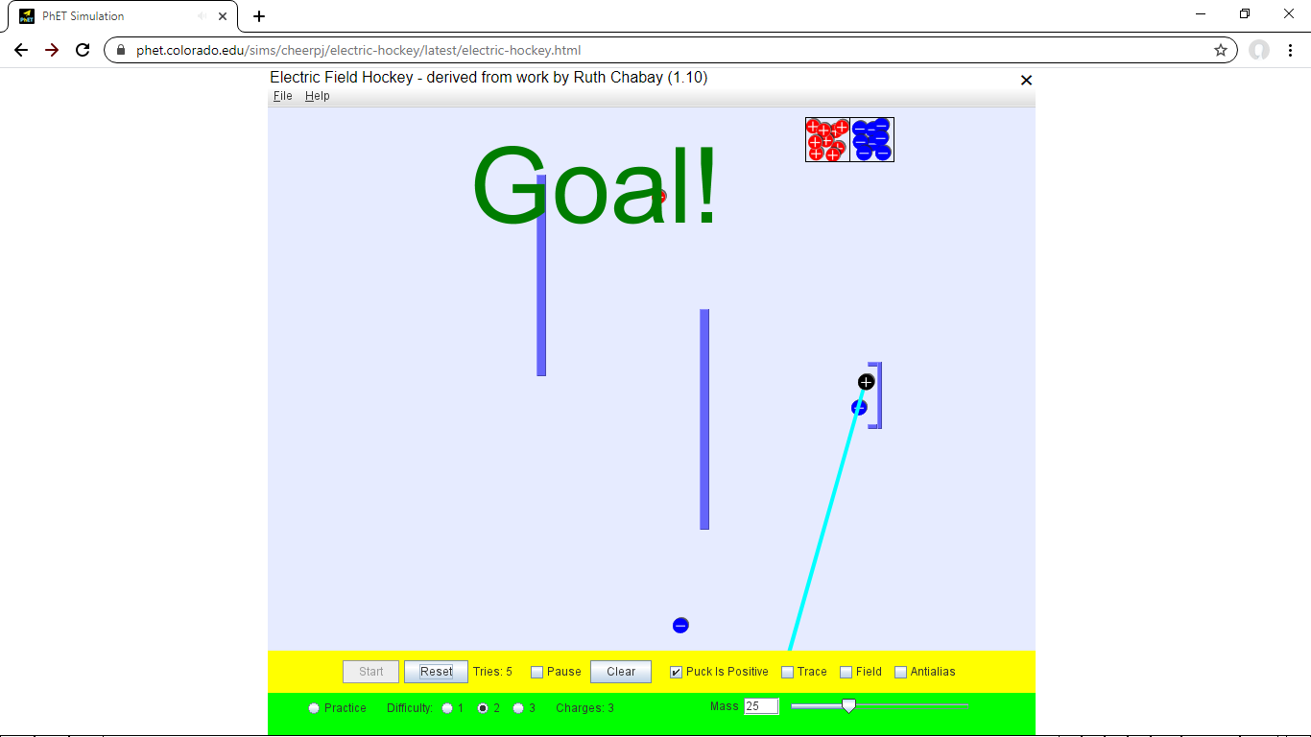
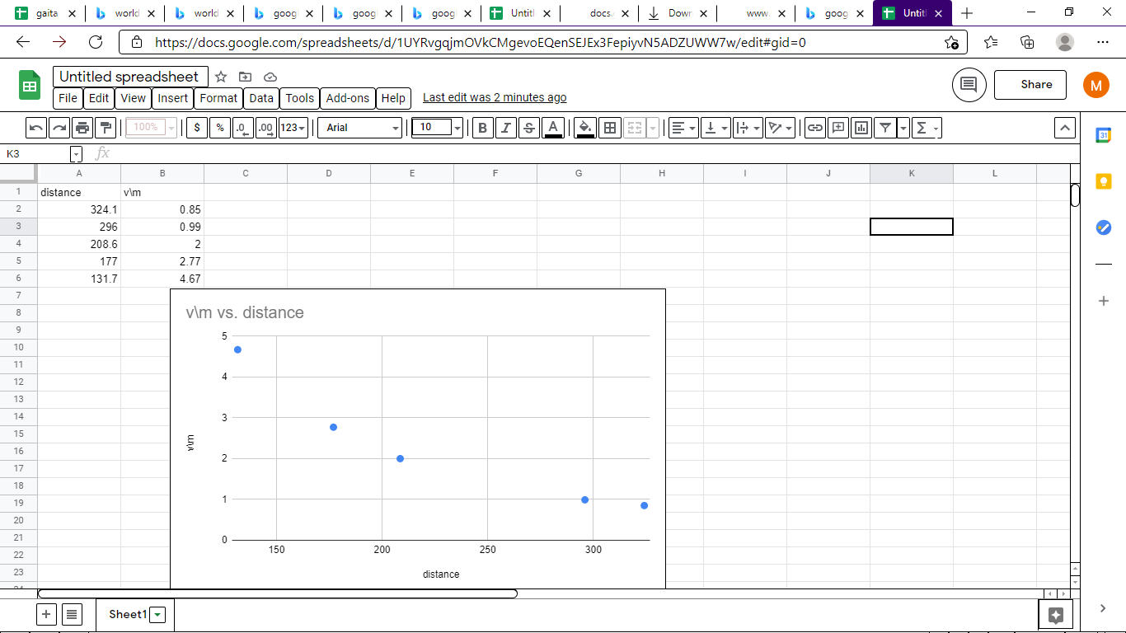

B .For negative particle

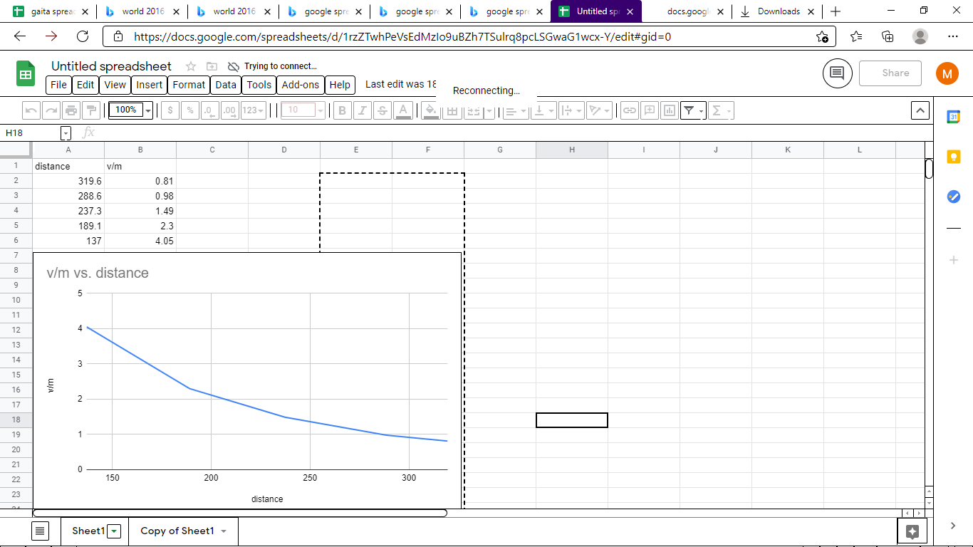
E=K.Q/d2 where Q is charge per coulomb and d distance

- 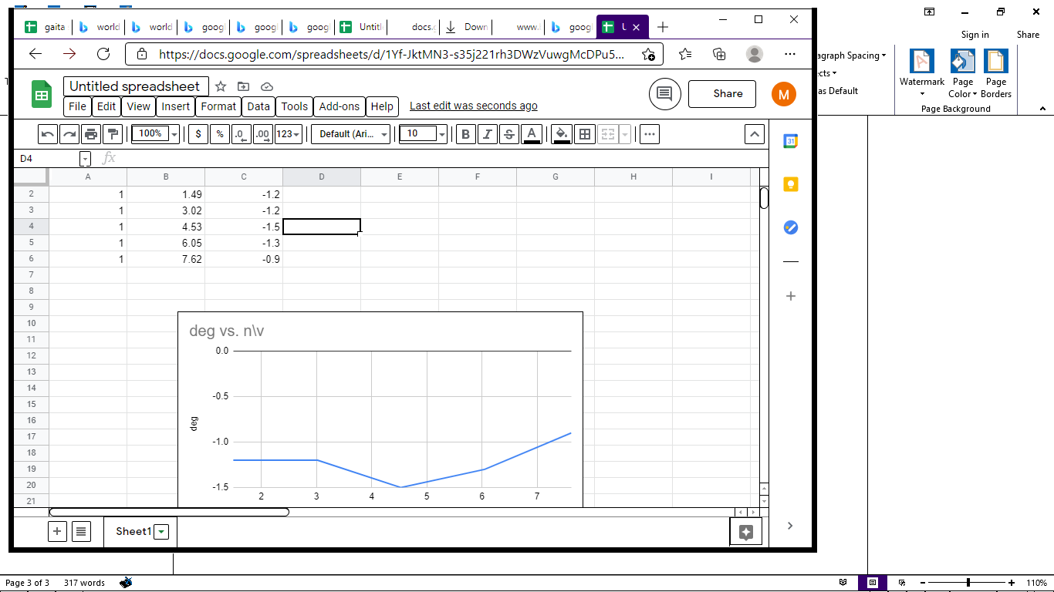

5.how electric force are like gravitational force
They are both attracted to bodies eg the earth while the electric field are attracted by other fields
They both act in a free space known as vacuum.
They are both consecutive ie they conserve energy
They both obey the inverse square law

Differences
Gravitational force is the force experienced as a result of mass while electrostatic is a force experienced due to charge.
Gravitational force is a very strong force while electrostatic is a very weak force

